1. The Exponential Distribution
The exponential distribution is used to estimate arrival times (queuing analysis) and failure rates (failure analysis) in many applications.

Examples of Events Modeled by Exponential Distributions

- Time between arrivals of cars at bridge
- Times between failures of internet service
- Hours of use until a new lightbulb fails

The exponential distribution should not be confused with the Poisson distribution. The Poisson distribution estimates the number of events that occur in a spVecified time period. The exponential distribution estimates time between events occurring, or time until the next event. (The two distributions, however, are mathematically related.)

Assumptions

- Arrivals are distinct events (two arrivals do not occur at once)
- Arrivals are statistically independent (one event does not influence probability of another occurring)
- Rate of arrival is constant over time

The exponential distribution is determined by a single parameter, λ:

λ = number of arrivals/events in a given unit of time

The probability density function for the length of time between events is:

f(X) = λe^{– λx} for X > 0 [Eq. 13.1]

The mean (average) time between events is:

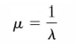

The standard deviation of time between events is:
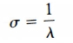

Cumulative probability:

Pr(arrival time ≤ x) = 1 – e ^{–λx}

Example: The time to service a customer at a bank has an exponential distribution with a mean of 3 minutes. What is the probability that a customer will take more than 5 minutes?

If mean time between events is 3 minutes, average no. of events per minute (λ) = 1/3.

Pr(arrival time > 5) = 1 – Pr(arrival time ≤ 5)
= 1 – (1 – e ^{–(1/3) × 5})
= e ^{–(5/3)}
= .189.

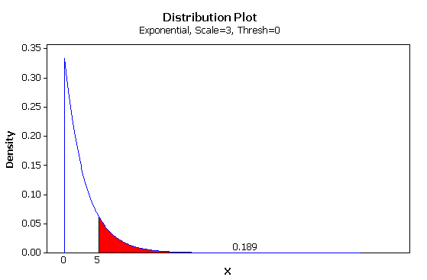

Time Until First Event/Failure

Above we have been talking about time between events (TBE). A related use of the exponential distribution is to predict time to (until) an initial failure (TTF). If a unit is functioning, the probability of failure in the within the next x units of time is:

f(X) = e^{– λx} for X > 0 [Eq. 13.2]

(compare with Eq. 13.1)

Calculating the Exponential Distribution in Excel

EXPONDIST(x, lambda, cumul)

x = time interval being considered
lambda = expected rate (mean no. of events per unit of time)
cumul = 0 (noncumulative)
= 1 (cumulative probability

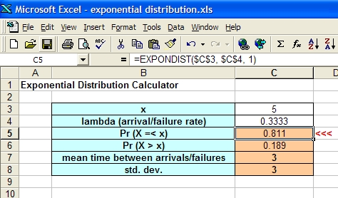

Example

Jobs are sent to a printer at an average of 3 jobs per hour. (a) What is the expected time between jobs? (b) What is the probability that the next job is sent within 5 minutes?

Answers:
(a) 0.333
(b) 0.221

For more information:
http://en.wikipedia.org/wiki/Exponential_distribution

2. The Weibull Distribution
An assumption of the exponential distribution is that the probability of an event/failure is constant over time. In many real-world situations this is inaccurate. Often the probability of a part's failing, for example, increases in proportionately to the time in use or operation. The Weibull distribution is a generalization of the exponential distribution that accounts for this.

The Weibull distribution contains parameters that reflect the change in rate of occurrence as a function of time. When the rate is held constant, the Weibull and exponential distributions are identical.

3. The Central Limit Theorem and Sampling Theory
Definitions

Sampling. The repeated drawing of samples of size n from a population.

Sampling distribution of the mean. The probability distribution (probability density function) that the mean of a sample of size n will have any given value. value.

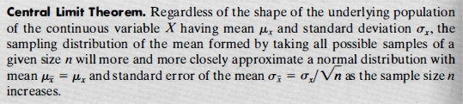

Motivation

Understanding the probability distribution of the sample mean will help us to determine how accurately a sample mean of size n estimates the true population mean. If the sampling distribution has a large standard deviation, chances are that a single sample mean isn't a very good estimate of the population mean.

As sample size (n) becomes larger, the standard deviation of the sampling distribution always decreases. The larger n is, the more likely it is that a sample mean is a good estimate of the population mean. An estimate of the population mean of any specified level of accuracy can be obtained with a large enough sample size.

Video
http://www.youtube.com/watch?v=JNm3M9cqWyc

Demonstration
http://onlinestatbook.com/2/sampling_distributions/SampDist_v1.html

Homework:

Read pp. 209–210.
Download exponential distribution calculatior (exponential_distribution.xls) from class website.
Examine formulas therein.
Use to work Prob. 5.34.

Read pp. 213–215 & first 1/3 of p. 216.

